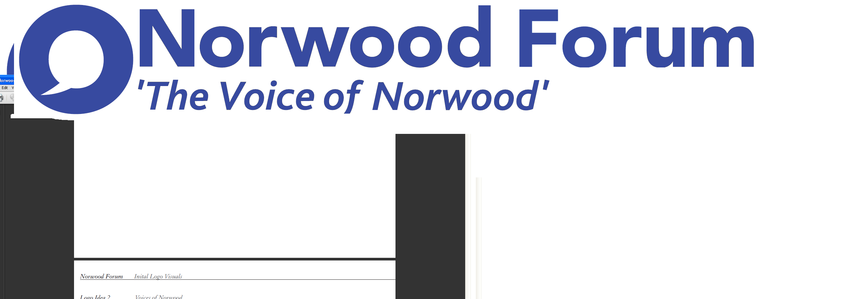
info@norwoodforum.org
Norwood Forum Committee
Wednesday 5 April 2017 at 7:00pm
The Old Library 14-16 Knights Hill SE27 0HY
Minutes
Present: Colin Fenn (CF), Sharon Fuller (SF), Su McLaughlin (SMcL), Gloria Orosungunleka (GO), Noshir Patel (NP) (Chair) and Sunil de Sayrah (SdS) (Treasurer)
Apologies: Jan Ware (JW) (Secretary)
Also present: Sarah Coyte (SC) (Lambeth Council), Elsie Gardner (Norwood Pensioners Group - item 2 only) and Tim Stephens (TS) (Administrator)

- Declarations of interest
None.
- Norwood Pensioners Group

Elsie Gardner Norwood Pensioners Group (NPG) attended to thank the Committee for the community grant awarded in June 2016, advise how the money had been spent and on the current parlous state of the Group’s finances. Currently, NPG would be able to continue to operate for a few more months until the summer holidays.

NPG continued to provide four weekly classes: flower arranging, Tai Chi, seated exercise and line dancing. Income was £150 per week (from class fees) but expenditure was £200 (tutor fees and room hire). The operation had been reviewed in discussion with the members, and class fees had been raised to £5. The Rathbone Society allowed the room hire at a reduced rate. The all day programme had originally been established with guidance by the Council, which used to grant fund the organisation. A previous attempt to seek volunteer tutors had been unsuccessful, and the paid tutors were all popular.

The preference was to maintain the current number of classes with a weekly frequency. An increase in membership was seen as the best way to increase income; 10 more members would mean a break even position would be achieved. Also, NPG was working with four other groups via Gateway to jointly work to raise funds. A stall was planned for the June West Norwood Feast.

The Committee discussed ways in which it could assist NPG and decided:

- CF: to discuss with Norwood Feast ways it could assist, in addition to providing the stall in June.
- SF: to produce an article with photo for the second April newsletter.
- SdS: to advise NPG on the next community funding event.
- All: to give thought to possible long term solutions, including social media.

- Committee membership

Colin Fenn was formally nominated by NP, seconded by SdS, and it was agreed unanimously to appoint Colin to the Committee.

- Minutes of last meeting (8 March 2017) and matters arising
The minutes of the meeting held on 8 March 2017 were approved. The following matters arising were discussed:
CLIPS
SdS had heard informally from Councillor Fred Cowell. Some 1200 ideas from 700 households had been collated from the CLIPS consultation and other surveys (e.g. the Streetworks out of scope ideas). Support for Norwood Park, Brockwell Park and environmental improvements at Norwood High Street and Auckland Hill had all been mooted. The Norwood pot was thought to be only £30,000, but the Council was giving further consideration to the cros-borough formula for allocating monies to wards. The role of NPA in decision-making on allocation of CLIPS funding needed to be clarified.
Waylett Place

The future possible involvement of Elemento remained unclear.
Norwood Park film screenings
NP had raised at the Cinema Steering Group the possibility of the planned free film shows being held at Norwood Park.
Actions
Delete actions 1 and 8.
- Norwood Planning Assembly
The Council had now started the formal consultation on the designation; the application included the unamended constitution as approved at the public meeting. The formal designation process would be included in the forthcoming newsletter.
NP encouraged all Committee members to put themselves forward for appointment to the NPA Executive. Currently, Norwood Forum was represented by SdS, and NP had been elected Vice-Chair at the public meeting.
Lambeth pubs and an article four direction: this had not been discussed at the previous day’s NPA meeting.

- West Norwood Cemetery HLF project

The Council had asked for an article on the HLF bid to be included in the forthcoming newsletter. CF outlined the reasons why the summary of the position on the HLF was not a full reflection of the position, and his concerns.
It was agreed that NP write (TS to draft) to the Council’s project officer (Joahanne Flaherty) to raise a series of questions with a focus on an understanding of how the HLF project (phase 1) would meet the now challenging timetable, and on improving involvement of the local community and Norwood Forum. The Council’s representation on the various bodies concerned would be raised with Councillor Jackie Meldrum.
- Lambeth Funding Network away day (18.03.17): report back
SC reported that LFN funding had been cut by the Council by 50% to £50,000, but this funding was guaranteed for three years. The guidelines for bidding for future funding would include a maximum bid of £5,000. Discussions were being held on crowd funding. SMcL also gave feedback.
The Committee would clearly need to give further consideration to alternative means of fundraising – e.g. membership fees and paid advertising, and alternative sources of grant aid.
A funding day was to be held for community groups on 10 May, and details are to be included in the second April newsletter.
- Thurlow Park zebra crossing meeting (21.03.17)

NP would raise with Councillor Anna Birley.
- Norwood Forum forthcoming meetings etc:

Open meeting (19.04.17): SdS reported on the ongoing arrangements

Training event ?May: SdS would raise with JW

AGM: new date of 1 July agreed, and would also include a community funding event. Item for next agenda.

- Streetworks
The job of Outreach and Communications Worker had that day been advertised. A meeting on future budgeting was to be held that Friday (NP/SdS/SC with Councillor Anna Birley and Randle Beckford).
- Chair’s report
NP had nothing further to report.
- Treasurer’s report
SdS would report on the 2016-17 year end accounts and a 2017-18 forecast at the next meeting.

- Forum communications
Norwood News: would be published the next day, after input from NP and SdS. SF was thanked for her work in producing the hard copy for local distribution. This had assisted in attracting some further 60 sign-ups at the recent Feast. SF would revamp the next printed copy as an A5 booklet, which would consist of an edited amalgam of the two April and first May newsletters, once provided with word versions (TS). Increasing the print run and using alternative printers were being considered. NP and SdS had met with the SE27 publisher to explore a possible regular Norwood Forum supplement.

Social media: further activity on Facebook and Twitter was encouraged.

Website: TS to re-contact possible local provider.

- Other business
St. Luke’s churchyard: CF was arranging a community planting event of the bare earth areas left after the recent car park upgrade. CF to provide details for newsletter.

Central Hill Estate: agenda item for next meeting.

Next meeting: Thursday 11 May at 7:00pm at The Old Library.

The meeting ended at 9:08pm.

Chair
Norwood Forum
Thursday 11 May 2017

Action Points {xx.xx.xx} dates = meeting when discussed) | Who | Completed?/  when to be discussed
- Website: revamp {30.06.16, 21.09.16, 09.11.16 & 09.01.17, 05.04.17} | TS | 11.05.17
- Website: wordpress training  {30.06.16, 21.09.16, 09.11.16 & 09.01.17} | TS | TBC once website agreed.
- Website: update current content {09.11.16} | JW
- West Norwood Cinema/Library: visit and update {07.12.16 & 09.01.17} | NP
- Tritton Road Pocket garden and People’s Fridge {07.12.16 – 05.04.17} | JW
- Norwood News: discuss at every meeting {09.11.16} | TS
- Streetworks spend on admin. and outreach/comms. {09.01.17} | NP/JW/SdS. | SW mtg. (07.04.17)
- Norwood Pensioners Group {05.04.17}:  - Norwood Feast assistance  - Norwood News article  - Advice on next community funding event.  - Ideas for long term solutions, inc. social media | CF  SF  SdS  All | 11.05.17
- Norwood Planning Assembly: Executive membership {05.14.17} | All
- West Norwood Cemetery HLF project: write to council {05.04.17} | NP (TS) | 11.05.17
- Accounts 2016-17, budget 2017-18 and future funding for Forum: ideas {05.04.17} | SdS with all | 11.05.17
- Thurlow Park zebra crossing {05.14.17} | NP
- Training event in ?May {08.03.17 & 05.04.17} | JW | 11.05.17
- AGM & community funding event (01.07.17): ideas {08.03.17 & 05.04.17} | TS & SdS | 11.05.17
- Central Hill Estate: agenda item next meeting {05.04.17} | TS | 11.05.17

