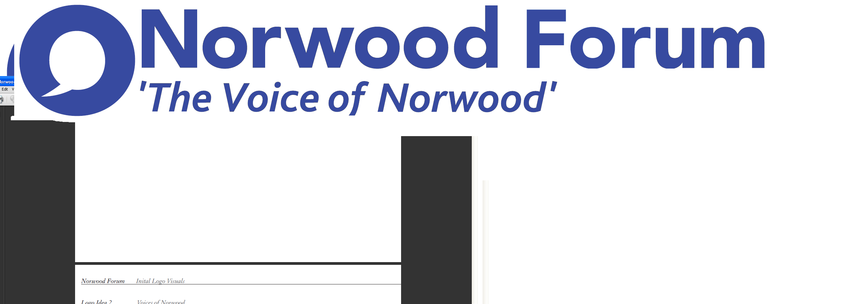
info@norwoodforum.org
Norwood Forum Committee
Thursday 11 May 2017 at 7:00pm
The Old Library 14-16 Knights Hill SE27 0HY
Minutes
Present: Colin Fenn (CF), Sharon Fuller (SF), Su McLaughlin (SMcL), Gloria Orosungunleka (GO), Noshir Patel (NP) (Chair), Sunil de Sayrah (SdS) (Treasurer) and Jan Ware (JW) (Secretary)
Apologies: Councillor Fred Cowell (FC); and Sarah Coyte (SC) (Lambeth Council)
Also present: Rik Gadsby (part) and Tim Stephens (TS) (Administrator)
Note: minutes are in agenda order rather than the order of discussion at the meeting.

- Declarations of interest
None.

- Minutes of last meeting (5 April 2017) and matters arising
The minutes of the meeting held on 5 April 2017 were approved. The following matters arising were discussed (some are listed under the minutes below):
Hustings
As SdS had not heard back from enough candidates, the event was now postponed to Wednesday 31 May. SdS would seek involvement of all candidates, NP would ask AP to Chair, and JW would seek to rearrange the booking at Portico Gallery.
Norwood Pensioners Group
Graphics had been produced and appeared in that day’s newsletter (TS to send to CF for use by Feast). U3A had given helpful advice. Elsie Gardner wished to continue with the flower arranging class despite the losses involved and competition from another class.
Constitution
JW queried the need for a post of Secretary, and suggested the Constitution be updated and modernised. JW/SMcL/CF and TS to meet to produce a draft amended version.

Health walks from West Norwood Health & Leisure Centre (Wednesdays)
TS to circulate details.
Actions
Delete items: 1, 2, 3, 5, 7 and 8.

- AGM and community funding day: Saturday 1 July 2017

Timetable (tabled): approved, subject to deadline for community funding applications being 19 June.
Community funding applications: criteria and application process would be stricter than in the past, but balanced. Responsibilities of funding recipients would be clearer. SdS would finalise and clear with CF, SF and JW.
AGM etc. agenda: add refreshment/networking break after initial community funding, and any questions slot at the end.
Nomination form and notes: no comments
Committee attendance record 2016-17: noted
Chair’s report (NP): not discussed
Treasurer’s report: not discussed (see item 12 below)
Roles at AGM: to be discussed at the next meeting (TS was unable to attend).
- West Norwood Cemetery HLF project
The letter to the Council as agreed at the last meeting had been drafted but not sent. Instead, Anne Kingsbury (to be appointed as the community representative on one of the West Norwood Cemetery bodies) had been able to establish some responses to points raised by CF at the previous meeting. NP would send to CF. TS to draft a newsletter article based on the recent Advisory Group meeting notes (which included an application for an extended deadline on HLF Phase 1). Response to be sent back to the Council (Joahanne Flaherty) for any observations prior to publication in newsletter. The AGMs for the two groups were to be held shortly:
Scheme of Management Committee: 12 July 2017
Advisory Group: 14 June 2017
- Norwood Planning Assembly
The Steering Committee now included additional people and a constructive meeting (attended by NP and SdS) had recently been held. Provided designation was received in July, work would commence in earnest in September 2017.
There had been a presence at Feast, in order to raise NPA’s profile. The focus group convenors and members were not currently involved; NP would ask NPA to contact them with an update and seek their involvement.
- Central Hill Estate

Councillors had yet to provide a summary of the Council’s reasons for the redevelopment, and NP would press further, as being able to provide both sides of the argument in a newsletter item or meeting would be a useful aid for the community.
- Thurlow Park Road zebra crossing

TS to seek written note from Councillor Fred Cowell.
- Norwood Forum Training event

As this would not be held before September at the earliest, this issue would be discussed at a Committee meeting after the AGM.

- Norwood Forum website

Rik Gadsby attended for this part of the agenda. He outlined his new website proposal, skills and experience, and answered questions:
- Recommended platform: Drupal (more functionality than wordpress (which is not future proofed)). This would ensure the necessary boost in google.
- Host: Events Everywhere server
- Email service: provision of a basic service hosted on Rik’s server at zero cost. Existing emails hosted by nanohost would need to be downloaded before transfer. info@norwoodforum.org is retained. Alternatively, and perhaps later, a google email service could be provided – likely cost of £3 p.mth per address. payable to google for hosting email service via google suite. He would check to see if this would also be free for voluntary organisations such as Norwood Forum (service is free for registered charities).
- The necessary liaison with nanohost.
- Mailchimp should be retained for the newsletter; a link to the mailing list would be provided so new subscribers would be automatically added
- Events management tool: included
- Local businesses: paid for ads and interactive maps were not recommended as these would duplicate existing provision and the level of required traffic was unlikely to be achieved. A list of businesses could easily be included.
- Training: one session for the whole committee, with a pdf of training notes
- Timescales; formal proposal to be sent the next day; completion within 10 weeks.
Also, he would like to get more involved in the local community Forum's activities.
After Rik left, the Committee discussed and agreed the following details:
- Cost: £1500 to include first year hosting (£200), website registration (with automatic annual renewal) email migration, training session for whole committee and a pdf guide, availability to trouble shoot and advise. £200 hosting cost each year thereafter
- Payment terms: 50% at start and 50% on completion
- Responsibility for updating the website would need to be considered. By training the whole committee there would be the opportunity to share the responsibility or assign one person.
- Progress and implementation: JW with any required support from TS.

- Streetworks
Cyclists and the Ira Court section of Norwood Road: a response had yet to be sent by the Council, despite a number of prompts.
Greening: CF would send Councillor Anna Birley (c.c NP) details of a community proposal to commemorate Jo Cox on the land outside the former probation centre. CF highlighted the need for such works to be capable of accommodating Feast, should Feast expand down Norwood Road.
- Chair’s report
NP had nothing further to report.
- Treasurer’s report
SdS had closed the 2016-17 year end accounts and established the carry over to 2017-18. He would report in detail to the next meeting.
NP would circulate details of a funding proposal.
- Forum communications
Newsletter: had been published that next day. JW would explore publishing on Norwood Forum and West Norwood Local facebook pages. It was agreed that JW place paid facebook advertisements for the AGM and community funding events.

Hard copy newsletter: SF would now produce an edited amalgam of the two April and first May newsletters.

SE27 publisher: NP would chase publisher.

- Other business
Dogs in parks: the recent dog attack in Norwood Park and responses from the community was noted.

Next meeting: Thursday 15 June at 7:00pm at The Old Library.

The meeting ended at 9:18pm.

Chair
Norwood Forum
Thursday 15 June 2017

Action Points {xx.xx.xx} dates = meeting when discussed) | Who | Completed?/  when to be discussed
- Website: revamp {11.05.17} | JW (TS) | 11.05.17
- West Norwood Cinema/Library: visit and update {07.12.16 & 09.01.17} | NP
- Norwood News: discuss at every meeting {09.11.16} | TS
- West Norwood Cemetery HLF project: write to council {05.04.17 & 11.05.17} | NP (TS)
- Accounts 2016-17, budget 2017-18 and future funding for Forum: ideas {05.04.17 17 & 11.05.17} | SdS with all | 15.06.17
- Thurlow Park zebra crossing {05.14.17 17 & 11.05.17} | TS
- Training event ?September {08.03.17, 05.04.17 & 11.05.17} | JW | ?July 2017
- Central Hill Estate: Council’s case and way forward {05.04.17 & 11.05.17} | NP
- Hustings event (31.05.17) | SdS/JW/NP
- Constitution review {11.05.17} | JW with SMcL/CF/TS
- Community grants: criteria {11.05.17} | SdS with JW, SF/CF
- AGM: roles and detailed arrangements {11.05.17}

