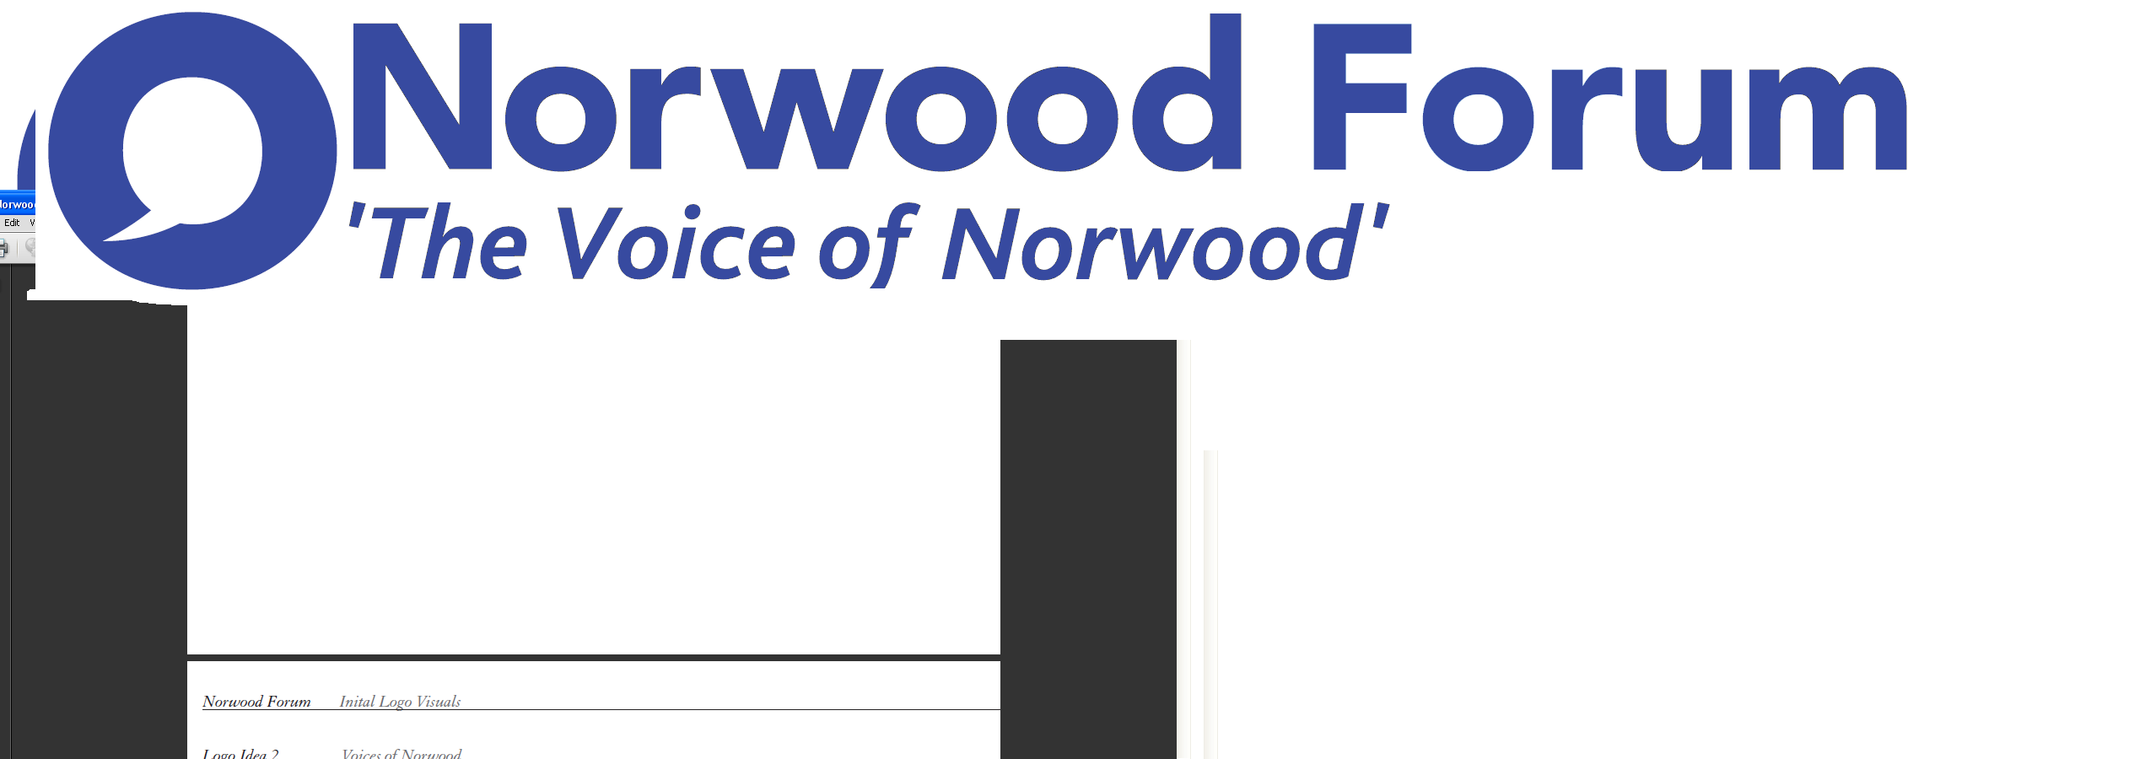
info@norwoodforum.org
Norwood Forum Committee
Thursday 20 July 2017 at 7:00pm
The Old Library 14-16 Knights Hill SE27 0HY
Minutes
Present: Colin Fenn (CF), Sharon Fuller (SF) (part), Su McLaughlin (SMcL), Gloria Orosungunleka (GO), Noshir Patel (NP) (Chair), and Jan Ware (JW)
Apologies: James Goodman (JG) and Sunil de Sayrah (SdS) (Treasurer); Councillors Fred Cowell (FC) and Luke Murphy; Sarah Coyte (SC) (Lambeth Council)
Also present: Tim Stephens (TS) (Administrator)
Sharon Fuller (first hour) and Gloria Orosungunleka in the Chair
Note: these minutes follow the agenda order, and not necessarily the order of discussion at the meeting.

- Building social cohesion and counter extremism within Lambeth
Rupert Sutton, Community Coordinator Counter Extremism (Lambeth Council) explained his role and the pan London and national positon. There would be 10 home office funded local authority based London coordinators and 45 coordinators nationally. The creation of the posts followed an assessment of the importance of the local context in countering terrorism and challenging extremism. The ultimate aim of the role was to create a more resilient community. He was establishing the local problems and challenges, considering historical crime patterns, meeting with local people and those who deliver local services, and assessing what is being done to build democratic participation. His support role included identifying funding sources and assisting organisations in making applications, work to stop people becoming radicalised, assist community groups in Lambeth, and give advice on any extremism issues.
In response to questions from Committee members, Mr Sutton:
- Would circulate details of the Building a Stronger Britain In-Kind Support Fund
- Confirmed he was to meet with the congregation of the local mosque
- Advised that Lambeth was assessed at Tier 2 in terms of support required
- Advised that various literature would be produced
- Would draft an article for the next Forum newsletter.
NP thanked Mr Sutton for his attendance.

- Central Hill Estate regeneration
Councillor Luke Murphy was unable to attend this meeting.
- Declarations of interest
CF and SF would not be present when the community funding applications were discussed.

There were no other declarations of interest.

- Minutes of last meeting (20 June 2017) and matters arising
The minutes of the meeting held on Thursday 20 June 2017 were approved, subject to correction of the typo on date of the next meeting on the last page.
The following matters arising were discussed, the others being already listed on the agenda:
Website revamp: all to view the new draft website and send comments to all by Thursday 27 July (https://norwood.mmlhosting.co.uk/). JW and TS would then meet with Rik Gadsby to finalise the draft site. All would need to attend the (to be arranged) training session, and decisions would be needed on individual responsibilities for uploading and ongoing updating of particular sections.
Cinema/Library: no update was available as yet as the Steering Group had not been meeting. There were local concerns on the London Living Wage campaign by Brixton Ritzy workers, and uncertainty as to whether living wage was to be paid at West Norwood by Picture House (JW would check the position on previous statements made). It was agreed that committee members would attend the Friends of West Norwood Library AGM (Thursday 27 July at 7pm at Portico Gallery) and ask pertinent questions. NP to produce article for next newsletter.
West Norwood Cemetery HLF bid: CF was to meet with Anne Kingsbury and John Price the next day.
Accounts/funding: SdS to advise if any further discussion was required on 2016-17 and 2017-18. Additional funding would need to be sourced from elsewhere.
Thurlow Park zebra crossing: no further news.
Training event for local community: for discussion in September; JW would consider how to seek views on requirements.
Constitution review: all to read current version and advise on any ideas for a revamp: http://norwoodforum.org/about-us/constitution/

Post AGM discussion on future objectives and roles: agreed to hold a special informal meeting on Monday 21 August at 4pm, subject to absentees being able to attend. The AGM had been a success; there had been some issues around the dementia café funding application.

- Community funding bids:
Deerbrook Surgery: SF apologised for being unable to arrange the submission of the form and asked that this be considered at the next meeting.
St Luke’s Church planting: CF had submitted the written application for funding of £250; this had been circulated before the meeting and copies were available. CF left the meeting. After discussion, the application was approved in full.

For next year:
- the application process would be brought forward as earlier deadlines would enable issues to be resolved before the AGM
- Scrutiny to be undertaken by the Committee as a whole

- Waylett Place
The promised walkabout had not happened, and info on the location of existing paypoints (i.e. alternative method to pay by phone payment/registration). The possible removal of the gates had therefore not been further explored (officers maintained that estimates on removing the fence were realistic given works required to remove and make good).
- Streetworks

A long list of outstanding issues was to be discussed at the Steering Group meeting the following week. Attendance had been poor recently, and the collaborative aspects of the project not so prevalent.

- Norwood Road: Thames Water works
The promised weekly updates would be sought from the Council.

- Lambeth Voluntary and Community Sector Conference 2017
GO and SMcL reported on the discussions on the developing Lambeth Voluntary and Community Strategy, being supported by Equinox Consulting and Lambeth officers and the training session on crowd funding. SMcL would circulate the PowerPoint slides, with commentary.
- Norwood Planning Assembly
The designation application had been approved by Lambeth Council’s Cabinet (03.07.17). A meeting with Council officers was to be held on Friday 28 July and as NP could not attend GO would advise if she was able to attend.
- Chair’s report
NP had nothing further to report. NAG had reported the vandalism at Brockwell Park lido, and Committee members commented that local instances of vandalism, anti-social behavior and moped theft were increasing.

- Forum communications
Newsletter: include article on Community Pharmacies if not already published.

- Other business
None.

Next meetings:

Thursday 17 August at 7pm
Monday 21 August at 4pm – special meeting on objectives and roles for the year. Subject to absentees being able to attend.

The meeting ended at 9:25pm.

Action Points {xx.xx.xx} dates = meeting when discussed) | Who | Completed?/  when to be discussed
- Website: revamp {11.05.17 & 20.07.17} | JW (TS) | 14.09.17
- West Norwood Cinema/Library: newsletter article following Friends AGM {07.12.16 & 09.01.17} | NP | 14.09.17
- Norwood Forum newsletter: discuss at every meeting {09.11.16} | TS
- West Norwood Cemetery HLF project {05.04.17, 11.05.17, 15.06.17 & 20.07.17} | CF | 14.09.17
- Accounts 2016-17, budget 2017-18 {05.04.17 11.05.17 & 15.06.17} | SdS | when necessary
- Thurlow Park zebra crossing {05.14.17 & 11.05.17} | NP
- Training event for local community {08.03.17, 05.04.17 & 11.05.17} | JW | 14.09.17
- Constitution review {11.05.17 & 20.07.17} – ideas for changes | All  JW with SMcL/CF/TS | 14.09.17
- Central Hill Estate: Council’s case and way forward. Discussion with Cllr Luke Murphy {05.04.17, 11.05.17, 15.06.17 & 21.07.17} | NP
- Waylett Place: feedback from walkabout {15.06.17 & 20.07.17} | NP | 14.09.17
- 24/7: inset or feature article {15.06.17} | NP/SdS | 14.09.17
- Norwood Forum logo strapline {15.06.17} | NP/SF | 14.09.17
- Community funding bid: Deerbrook Surgery {20.07.17} | SF | 14.09.17
- Building social cohesion and counter extremism within Lambeth: newsletter article and any further follow up action {20.07.17} | TS | 14.09.17

