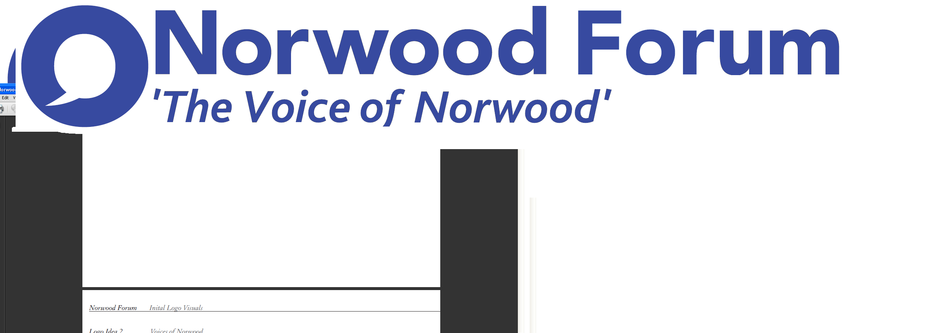
info@norwoodforum.org
Norwood Forum Committee
Thursday 15 June 2017 at 7:00pm
The Old Library 14-16 Knights Hill SE27 0HY
Minutes
Present: Colin Fenn (CF), Sharon Fuller (SF) (part), Gloria Orosungunleka (GO), Noshir Patel (NP) (Chair), Sunil de Sayrah (SdS) (Treasurer) and Jan Ware (JW) (Secretary)
Apologies: Su McLaughlin (SMcL),
Also present: Councillor Fred Cowell (FC) (part); and Sarah Coyte (SC) (Lambeth Council); and Tim Stephens (TS) (Administrator)

- Chair and Declarations of interest
It was agreed that SdS chair this meeting, with a rotating Chair for the next meeting (it was mooted this be: SF and then GO (once Sharon had to leave)).

There were no declarations of interest.

- Minutes of last meeting (11 May 2017) and matters arising
The minutes of the meeting held on Thursday 11 May 2017 were approved. The following matters arising were discussed, the others being already listed on the agenda:
Cinema/Library: no update was available as yet.
Central Hill Estate: NP would ask Cllr Luke Murphy to attend the next meeting to brief on the Council’s position on the Council’s position on the regeneration of the estate.
Constitution review: no progress as yet.
Delete item 9: hustings event.

- AGM and community funding day: Saturday 1 July 2017

Timetable (revised): approved, subject to:
- SdS to update existing newsletter items
- Committee officers, SF and GO to meet on 27.06.17 (3:30pm?) to consider both community grant applications and committee nominations
- Deadline for community funding applications to now be the same as for committee nominations: 24.06.17 (noon) {this subsequently changed to 27.06.17}
Community funding applications: JW would send out the necessary information on the deadline, criteria, and application form. This would go to the six or so organisations who had sought information (including Deerbrook Surgery Christmas party), and the existing list of potential applicants.
Chair’s report: NP would produce a written report with assistance from SdS (NP/SdS to meet 27.06.17 (10:30am))
Treasurer’s report: see next minute.
Roles at meeting:
- Refreshments: JW
- Welcome/signing of attendance sheet/handing out code of conduct: SF and GO
- Chair and timekeep presentations: NP
- Voting process (control and count): SdS and Jill
- Draft Minutes: SdS

SdS would arrange printing of all documentation (TS to send).
Committee nomination forms were completed by most existing committee members. Deadline for submission: 24.06.17 (12 noon).

Noted with regret JW’s decision to stand down both as Secretary and Committee member.

Post AGM discussion on future objectives and roles: NP reported the wish to discuss future objectives and roles with the newly elected committee at the next meeting.

- Treasurer’s report
SdS tabled the 2016-17 year end and 2017-18 year to date accounts, showing an in-year surplus of £879. The draft 2016-17 accounts were approved for submission to the AGM, subject to the deletion of the notes (including details of the separately held Streetworks accounts).
For 2017-18 the maximum LFN grant would be £5,000. NP would include in Chair’s report the likely reality of a reduction in community funding in 2017-18 – less grants or less/variable amounts would be available.
- West Norwood Cemetery HLF project
NP had asked Anne Kingsbury to serve also as the representative of Norwood Forum on the West Norwood Cemetery bodies.
Monoliths: the Advisory Group (14.06.17) had not accepted the Norwood Forum proposals, concluding that the monoliths should be sited on the crescent grassed area as it was considered this would not impact adversely on its use during Feast. The trail suggestion had not been supported. FC would happily pursue again the Norwood Forum suggestions; TS to circulate to all Committee members and then to FC.
Newsletter item (original proposed article from Joahanne Flaherty and revised version): TS to circulate to all Committee members.
Future visitor numbers: the HLF bid had envisaged attracting an additional 100,000 visitors, and there was a need to develop a strategy to achieve and accommodate such an increase in the use of the cemetery (as well as through the provision of a visitors centre).
- Norwood Planning Assembly
The Ward Councillors of the three wards had issued a statement of support for the designation application which was expected to be approved by Cabinet (03.07.17). FC would check no objections had been made, and attend the next possible NPA meeting (July) to discuss and plan the next steps and work required over the following two years.
FC would also now pursue a NPA public meeting about MDO site 18 (delayed by the general election).
- Thurlow Park Road zebra crossing

NP would seek details on progress from Councillor Anna Birley.

- Streetworks
Cyclists consultation event: Bon Velo 21 June 6-7pm.
Thames Water works: road congestion so far was not as severe as feared, and a southbound cycle lane had been installed.
Waylett Place: NP to write to FC on the tidy up proposals, need for the councillor walkabout and £10-12k cost of car park fence removal.
Car free day: would not now be held this year in West Norwood/Tulse Hill.
Norwood Road/York Hill/ Lancaster Avenue diagonal crossing art competition: the Steering Group (20.06.17) would consider officer proposals to reduce choice to five off the peg designs because of additional £5k plus cost of bespoke designs.
- Chair’s report
NP had nothing further to report.
- Forum communications
Newsletter: a revised list of items was agreed {and amended subsequently}.

Hard copy newsletter: SdS had arranged copying: 200 copies at £96 via SRA. Full colour would cost £430. Quarterly publication to be maintained for rest of year.

24/7: circulation of 5,000; 8 page insert would cost £350, with one page costing £86. NP & SdS would meet the editor to discuss further.

- Other business
Quietways: FC reported on the publication of the decision (proposed for 12.06.17) immediately before the general election, and objection by the Ward Councillors of the three wards on two main grounds: lack of involvement of local people in the design (scheme cost of £0.8m) and design of Rosendale Road/Thurlow Park Road junction. Ward Councillors were to meet with the Strategic Delivery team, and call-in the decision if change was not agreed. FC would brief NP on the outcome with a view to inclusion in the Newsletter if this was possible.

Lambeth Country Show: there would be an LFN stall, and an opportunity for Norwood Forum and Streetworks involvement.

Rosendale Road tree pits: local shopkeepers wanted to pay for planting and maintenance; suggestions needed for maintenance.

POP Norwood – requested planter: GO to suggest approach to Jason Prentis.

Norwood Forum strapline: further to previous discussions, NP suggested “connecting the community”. SF had been asked to do a mock up.

Norwood Park dog awareness session: formal application for £25 awaited.

Hustings room hire: invoice awaited. The event had been a great success, and Elmgreen School hall had been a most suitable venue.

Next meeting: proposed dates not discussed; Thursday 20 July at 7:00pm at The Old Library is provisional date.

The meeting ended at 9:18pm.

Action Points {xx.xx.xx} dates = meeting when discussed) | Who | Completed?/  when to be discussed
- Website: revamp {11.05.17} | JW (TS) | 21.07.17
- West Norwood Cinema/Library: visit and update {07.12.16 & 09.01.17} | NP
- Norwood News: discuss at every meeting {09.11.16} | TS
- West Norwood Cemetery HLF project: write to council {05.04.17, 11.05.17 & 15.06.17} | NP (TS)
- Accounts 2016-17, budget 2017-18 and future funding for Forum: ideas {05.04.17 17 & 11.05.17} | SdS with all | 15.06.17
- Thurlow Park zebra crossing {05.14.17 17 & 11.05.17} | TS
- Training event ?September {08.03.17, 05.04.17 & 11.05.17} | JW | 21.07.17
- Constitution review {11.05.17} | JW with SMcL/CF/TS
- Post AGM discussion on future objectives and roles {15.06.17} | TS to draft | 21.07.17
- Central Hill Estate: Council’s case and way forward. Discussion with Cllr Luke Murphy {05.04.17, 11.05.17 & 15.06.17} | NP | 21.07.17
- Waylett Place: write to FC on the tidy up proposals inc. fence {15.06.17} | NP | 21.07.17
- 24/7: inset or feature article {15.06.17} | NP/SdS | 21.07.17
- Norwood Forum logo strapline {15.06.17} | NP/SF | 21.07.17

