

Annual General Meeting
Saturday 15 July 2023 (2:15pm)
Minutes

Committee Members (2022-23) present: Anne Crane, Jane East, Kim Hart, Gloria Orosungunleka, Noshir Patel, Jane Pickard and Philip Virgo

Also present:
Councillors Ibtisam Adem (part), Christine Banton and Saleha Jaffer
The Revd. Jonathan Croucher: Vicar at Christ Church Gipsy Hill and Area Dean of Lambeth South in the Diocese of Southwark
Laura Rigden: incoming committee member
Nadeen Collington: Girls Mindset and Confidence:
Lorien Mowat: Friends of Norwood Park
John Price: Effra Pottery:
Approximately 26 other members of the public
Tim Stephens (Forum Administrator)

Apologies for absence:
Helen Hayes MP
Marina Ahmad AM
Lambeth Council: Councillors Judith Cavanagh, Fred Cowell, Olga FitzRoy, Jackie Meldrum, Rebecca Spencer and Sonia Winifred.
Committee member: Anne Crane

Kim Hart in the Chair

- Welcome from the Chair

Kim Hart welcomed everyone to the meeting, outlined the afternoon programme and listed apologies received. Kim also drew attention to the exhibition in the rear of the room featuring local environmental and sustainable initiatives and projects under the Forum’s new green banner: How Green Can We go:

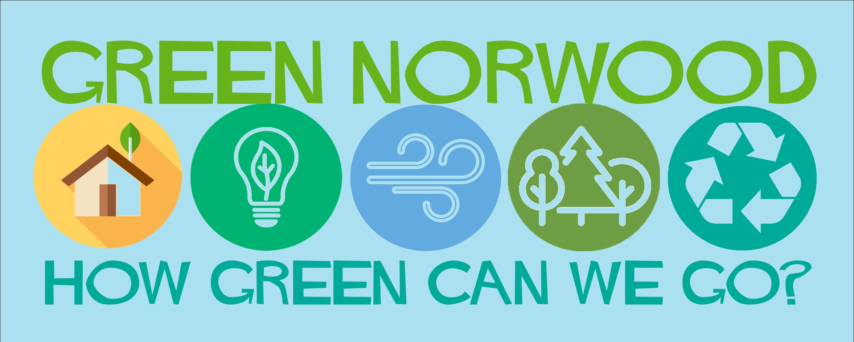
The slides and videos presented during the meeting can be accessed here.

- Helen Hayes MP and local councillors

Jane Pickard, Committee member, introduced the videos from our local politicians who had been unable to attend:

Helen Hayes MP
Helen had been unable to attend due to a longstanding family commitment. She thanked Norwood Forum for its success in fostering the local community and encouraging people to get involved in the continuing challenging issues affecting the area.

Many local people had been adversely affected by continuing illness, bereavement and the cost of living crisis. Things were tough too for the local independent businesses as inflation, business rates set by central government and the impact of the cost of living on people’s spending.

The Forum had been successful in encouraging the local community to get involved in the matters affecting the local community and there were big challenges coming up in the year – especially work to encourage local businesses to thrive once again and big planning issues.

She looked forward to continuing to work with Norwood Forum and local councillors as we all sought to work together on all these issues.

The Forum also heard from representatives of three of the local wards in our area; most had been unable to attend as they were required to undertake campaigning for the forthcoming Uxbridge By-Election:

West Dulwich Ward: Councillor Fred Cowell (by video)
Highlighted the need to address road transport in order to reduce air pollution through a reduction in both carbon emissions and air particulates (tyres and brakes). The number of cars on UK roads and motor car journeys had both risen and led to increased congestion. So both a shift to electric vehicles and a reduction in mileage by motor vehicles was required to achieve a greener local environment and net zero by 2030. The West Dulwich Ward traffic controls consultation had recently closed and the outline proposals would be amended to reflect the responses received. There had been other activities as well such as improving pedestrian facilities: widening the pavements on Norwood Road (the Streetworks programme) and some planting works (Streetworks and Station to Station). Lambeth had the highest number of adult bike journeys in South London. Improvements for cycling locally included the Rosendale Road cycle lane, increased cycle storage and work to ensure proper control over the parking of hire bikes. Lastly local public transport services needed to be maintained and access to local stations improved (West Norwood station was unique in having access to both platforms) and ticket offices protected. Bus services needed to be protected and journey times improved through measures such as bus lanes on main roads. Ideas on all these issues would be most welcome.

Gipsy Hill Ward: Rebecca Spencer (by video)
Welcomed the continued focus by Norwood Forum on addressing environmental issues. She outlined the daily casework of local councillors and gave a snapshot of some of the important issues in the ward. The Council had given a commitment to consult Central Hill Estate residents on estate improvements and there was the welcome commencement of the Roman Rise affordable housing development. Work was commencing on examining possible options for improving the play area near the Vale Street community shop, and very much involving local children in the feasibility work. In the context of Clean Air, projects being pursued included School Streets at Paxton School and Kingswood School. There had been successful tree planting in 2022-23 and the aim was to continue this into 2023-24.

St. Martin’s Ward: Councillor Saleha Jaffer (in person)
Welcomed the recent opportunity to jointly host a visit to the ward by the Chief Executive of Lambeth Council which enabled both the successes of past and ongoing initiatives and problems to be highlighted; she would report further on the outcomes. Working with her fellow ward councillor Olga FitzRoy, Norwood Forum and local residents progress was being made in persuading TfL to remove the Tulse Hill gyratory. The hoarding around the development on the corner of Norwood Road and Thurlow Park Road was about to be moved to allow the reopening of the bus stop and pavement (the developer would be recharged). The builder had gone bankrupt and news was awaited on continuing the build. The consideration by the Council’s Planning Applications Committee of the planning application for affordable housing at Avenue Park Road was awaited. The importance of community safety was recognised, and plans were well-advanced to establish a Safer Neighbourhood Panel for the ward.

- Health and Wellbeing

Jane East (Committee member) introduced the various Health & Wellbeing grant schemes which Norwood Forum had conducted:
- Gipsy Hill Health & Wellbeing grants 2022-23: funded by Lambeth Public Health
- Thriving Norwood 2023-24: funded by Lambeth Public Health
- Norwood Forum small grants scheme 2022-23: funded by Norwood Forum
The meeting heard from three grant recipients:

Friends of Norwood Park: Lorien Mowat
The seed funding had been directed at the community garden which had now grown to 13 plots operated by eight families of varying sizes. The work had been a significant catalyst for the expanded activity of the Friends with recently completed projects including tree planting, new signage and repurposing storm felled trees.

Effra Pottery: John Price
The project at West Norwood Cemetery had involved children producing figures to sail on the mythical River Effra fleet. The sculptures would be fired at The Portico using the traditional Japanese method of Raku - a natural firing process that relies on each of the elements: fire, air, earth and water. Vessels are fired at a low temperature for a brief amount of time, removed from the kiln when it has reached its highest temperature, and then left to cool.

Girls Mindset and Confidence: Nadeen Collington
A Girls Mindset Confidence and Self-Esteem Club to help girls improve their self-esteem and build confidence had been run alongside the Homework Club at Emmanuel Youth Club and for the children of parents (and carers) on low incomes. The weekly sessions engaged the children in activities to promote positive thinking, enhance mental capabilities and develop a positive mind set. had culminated in a talent show by the participants which had been well received by the parents and carers concerned.

The Chair thanked the presenting groups for attending to make their presentations and all grant recipients for running their schemes with such enthusiasm.

- Annual General Meeting

- Minutes of last meeting

No comments had been received, and the minutes of the last Annual General Meeting held on Saturday 9 July 2022 were approved.

- Chair’s Annual Report 2022-23

Kim Hart presented the written report covering the year’s activity, highlighting the activities using the Wheel of Wellbeing:

- Planet: care. The Environment
- Place: take notice. Place making
- People: connect. People connecting
- Body: be active. Know your neighbourhood
- Mind: keep learning. Wellbeing
- Spirit: give. Volunteering

In particular, the following activities were highlighted showing videos of:

Community - support: recipients of Norwood Forum small grants scheme
Community - campaigning: Windsor Grove demonstration outside Lambeth Town Hall
Community - green and sustainable: Wild Norwood, celebrating nature in an urban, inner London borough and its West Norwood Live! event in Tivoli Park

Kim finished by referencing the Forum’s volunteering programme: ‘In Any Language’, which seeks to embrace our whole community by recognizing the many different languages spoken across Norwood.

Everyone is welcome to become part of the Norwood Forum family however much time you have spare – whether it is 30mins a month or a day a week or …

- Treasurer’s Report

Noshir Patel (Treasurer) began by reviewing the volunteer hours for the past 12months, which showed a further increase on the past year, value now £54K:

He then presented the accounts for 2022-23, highlighting:

- Summary of Norwood Forum accounts for year to 31 March 2023: cash at bank: £3,081.96
- #ScrapTheYard donations to pay for acoustic consultant: ringfenced for future campaign work or if not needed, used for a community project as yet not discussed: cash at bank: £479.00.
- Streetworks operating and overheads grant: cash at bank: £6,693.00. Work underway to finally complete the Norwood Road phase and with TfL to relaunch the removal of the Tulse Hill gyratory was highlighted.
- Gipsy Hill Health & Wellbeing Grant (funded by Lambeth Public Health): cash at bank: £37.371.76

There were no questions raised on the accounts, which were received.

- Election of Norwood Forum Officers and Committee

The Committee membership for 2022-23 had been:

Chair:  Vice-Chair: | Kim Hart  Gloria Orosungunleka
Treasurer: | Noshir Patel
Committee members: | Anne Crane  Jane East  Jane Pickard
 | Philip Virgo

Kim Hart announced the outcome of the nomination process for the committee for 2023-24. As no positions were contested, a formal election ballot was not required and the 2023-24 Committee would be:

Chair:  Vice-Chair: | Kim Hart  Gloria Orosungunleka
Treasurer: | Noshir Patel
Committee members: | Anne Crane  Jane East  Jane Pickard
 | Laura Rigden
 | Philip Virgo

Kim Hart gave her thanks to those serving on the Committee in the last year and looked forward to working with the committee in the coming year.

Further volunteers to serve on the Committee and develop and lead on projects would be most welcome. The website: www.norwoodforum.org gives a picture of the work currently being undertaken.

- How green can we go?

The discussion was facilitated by The Revd. Jonathan Croucher: Vicar at Christ Church Gipsy Hill and Area Dean of Lambeth South in the Diocese of Southwark.

Please see attached notes of suggestions made by the audience.

- Close of meeting

The meeting gave a vote of thanks to Kim Hart for all the work undertaken, the creativity shown, and the delivery of the considerable achievements during 2022-23.

The meeting closed at 4:37pm.

Chair
Norwood Forum
13 July 2024

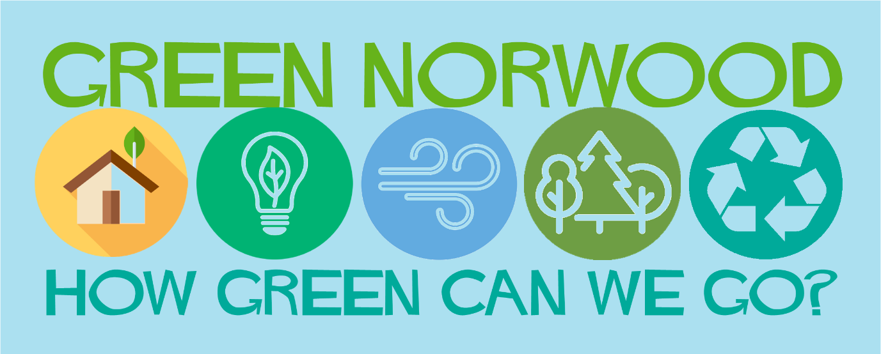
WORKING TOWARDS A GREENER NORWOOD
Transport
- Stop thinking LTNs are the only answer! It drives pollution from one area to another!
- Not opposing schemes to reduce traffic like LTNs – but community must be consulted and a genuine partner in anything like this
- Definitely LTNs are good but not before alternative transport options – public transport – have been put in place
- Less cars please! (this means more small buses up our hills)
- Campaigning for a 20mph limit on South Circular
- South Circular pedestrian crossings – promised action by TfL – dates? Before another tragedy
- More cycle paths
- Convenience of the car: should be the last option
Reducing waste
- Vale Street recycling – access – especially difficulties in pre-booking
- Flytipping! Change Vale Street to take everything on set days – not just green?
- Recycling of paint (put colours on lids?) – lack of facility at Vale Street
- Green newsletter with contacts of i.e. recycling agents ??
- Update/promote list of what you can recycle and where
- Is it true that most clothing donated to charity shops is skipped?
- Norwood Repair Shop welcomed
- Do we need a list of what, when and where that especially covers the lesser known such as the Repair Shop and Superdrug recycling pill blister packs?
Green Spaces
- Fix Norwood Park play area!
- Lack of drinking water in parks: must reduce use of plastic bottles – but how?
- Pavement weeds – good or bad?
- Norwood Park is neglected and bottom of the list politically (Lambeth)
- Safe gardens for Older/ disabled residents
- More green spaces – small parks and large parks (new ones!)
- More trees and plants – use of walls, roofs and streets
- Mores street trees
- Thoughtless growing of big trees close to buildings - lack of maintenance always seems to follow – then problems with subsidence for the buildings
- Lambeth – ridiculous to have to pay to have trees planted
- More green spaces – little and large
- Incredible Edible – compost project on some Lambeth estates – how can the rest of the community tap into this?

Miscellaneous
- Run more repair cafes for electricals and furniture
- Trees obscuring traffic lights
- Ban disposable vapes!
Traffic
- Is most of our traffic through traffic?
- Is most of our pollution from HGVs?
- Take away motorcycles: pollution – exceed speed limit - uninsured, unlicensed?
- Enforcement of 20 mph speed limits seems to be virtually non-existent
- Retail deliveries: large HGVs – how can that be improved?
- CPZs: reconsider rules on car ownership
- LTNs: what and why – needs better explanation and not one size fits all
- Electric cycling/scooters – use on pavements MUST be addresses
Large scale ambition - Long term planning
- Set up local renewable energy company
- Community solution – tap into the student body
- Local authority – what are they actively doing with their Climate Action Plan?
- More joined up thinking, more collaborative planning by Lambeth that involves the community
- Does the Lambeth Made project have potential within its apprenticeship scheme to bring additional sustainable resources to our neighbourhood?

________________________

