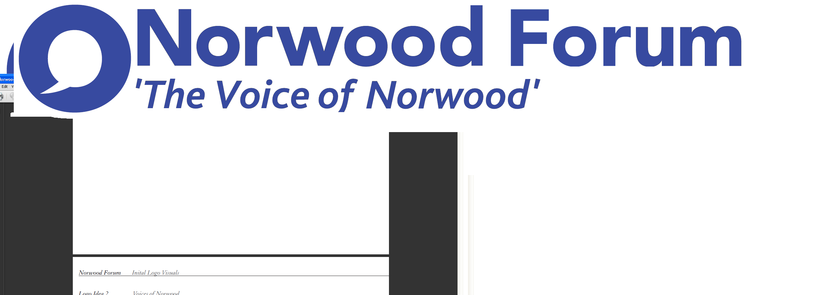
info@norwoodforum.org
Norwood Forum Committee
Monday 8 February at 7:00pm
The Old Library 14-16 Knights Hill SE27 0HY
Minutes
Present: Su McLaughlin (SMcL), Gloria Orosungunleka (GO), Noshir Patel (NP) (Chair), Sunil de Sayrah (SdS) (Treasurer), Sharon Fuller (SF); Councillor Fred Cowell (FC), Sarah Coyte (SC) (Lambeth Council) and Jan Ware (JW) (Secretary)
Apologies: Tim Stephens (TS) (Administrator)
Also present:

- Declarations of interest -
JW would not take part in any decisions on letting rooms at The Old Library for Norwood Forum business.

- Minutes of last meeting and matters arising
The minutes of the meeting held on 9th January 2017 were approved. The following matters arising were discussed:
Training opportunities from the Forum: SdS to discuss at next Committee meeting
The Tritton Road Pocket Garden: JW to consider article to promote the garden.

- Dalton Street and other planning issues
SF explained the proposed development of Daltn Street by Elemento of 17 apartments over 4 storeys + basement and no parking. Local residents were opposed to scheme. Over and above concerns about scale, parking, loss of historic buildings and businesses was a worry about the basement development impacting the water table and hence drainage.
FC spoke about (1) development of the laundry buildings, (2) Elemento’s interest in having control of the Waylett car park – Noshir to draft letter to council raising this point, (3) CLIP consultation gathered about 150 on-line notices and there is a street survey being done to increase this. The conclusion briefing will be in the first 2 weeks of March with a joint meeting of Forum and NAG.

- Norwood Planning Assembly
The Designation Application has been filed and feedback received from Lambeth. The NPA is working through the objections.

- Forum communications
SDS noted that the approved £1,500 SW budget to support the Forum has been transferred to our NF account and we have in total £2,400 in our IT budget.

TS to seek quotes from local contacts on a new website. Use Tulse Hill Forum and friends of Brockwell Park as examples. Possible platform: wordpress; possible email: gmail (retaining info@norwoodforum.org); automatic feed for Streetworks. Training to be included in package. JW to be the responsible officer.

Social media. As the Norwood Forum facebook page was not stand alone, it would not be possible to link mailchimp to that page. Paid advertisements should be considered for future events. As Norwood News would be published every other week on the Facebook page, every effort should be made to at least publish one story on the other weeks.

- Streetworks

It was noted that Georgina will be leaving as outreach/comms manager and that Sal is replacing Deborah. There will be 2 Public Meeting on the gyratory system: City Heights 28/2 and Salvation Army 7/3.

The Steering Group needs to take decisions on budget & outreach/comms for the remainder of the life of the project given the limited and diminishing resources available.

- Chair’s report / Treasurer’s report - Nothing further discussed.

- Any other business
FOWNP chair to join us at next meeting and we can discuss Hungry Hippo café and the proposed rent rise.

The meeting ended at 9:00pm.

Action Points {xx.xx.xx} dates = meeting when discussed) | Who | Completed?/  when to be discussed
- Newsletter: print copies and Rathbone cost estimate | SdS & JW | Pdf version available?
- Website: revamp {30.06.16, 21.09.16, 09.11.16 & 09.01.17} | TS
- Website: wordpress training  {30.06.16, 21.09.16, 09.11.16 & 09.01.17} | TS | Poss. Training course. MdS to discuss
- Website: update current content {09.11.16} | JW
- West Norwood Cinema/Library: visit and update {07.12.16 & 09.01.17} | NP
- Tritton Road Pocket garden and People’s Fridge {07.12.16 & 09.01.17} | JW
- Norwood News: discuss at every meeting {09.11.16} | TS
- LFN funding approved: plan required activity (including training opportunities) {07.12.16 & 09.01.17} | SdS
- Public meeting – March 2017: format and arrangements {09.11.16, 07.12.16 & 09.01.17} | All
- Streetworks spend on admin. and outreach/comms. {09.01.17} | NP/JW/SdS.

