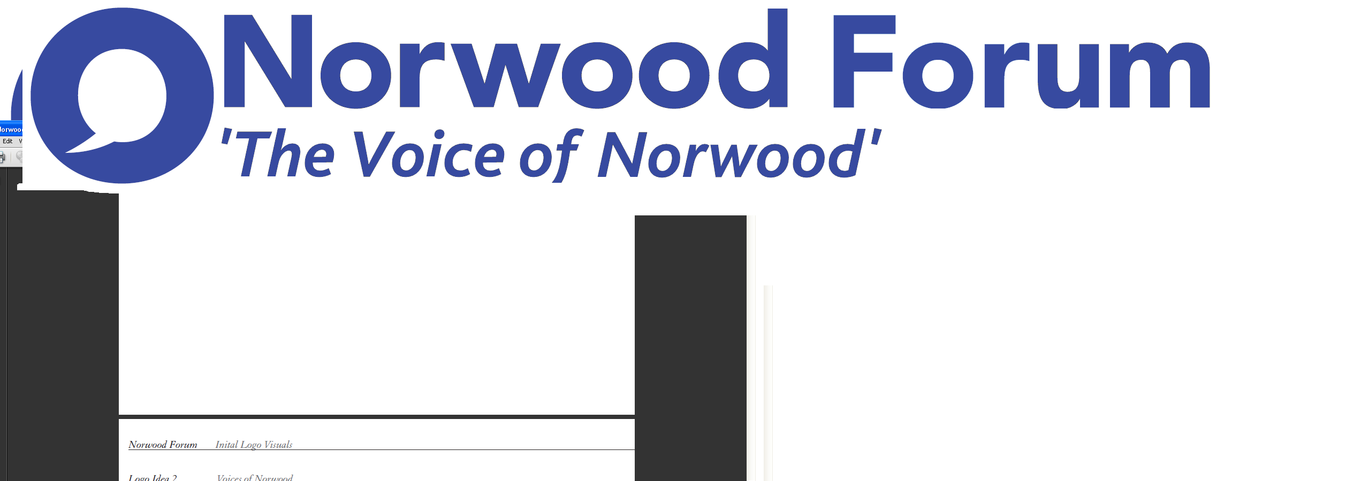
info@norwoodforum.org
Norwood Forum Committee
Monday 8 March 2017 at 7:00pm
The Old Library 14-16 Knights Hill SE27 0HY

Minutes
Present: Su McLaughlin (SMcL), Gloria Orosungunleka (GO), Noshir Patel (NP) (Chair), Sunil de Sayrah (SdS) (Treasurer), Sharon Fuller (SF), Sarah Coyte (SC) (Lambeth Council) and Jan Ware (JW) (Secretary)
Apologies: Tim Stephens (TS) (Administrator)
Also present:

- Declarations of interest
JW would not take part in any decisions on letting rooms at The Old Library for Norwood Forum business.

- Minutes of last meeting and matters arising
The minutes of the meeting held on 8th February were approved. The following matters arising were discussed:
CLIP: Noshir to chase FC on date of review meeting which was planned for first 2 weeks of March.

Waylett parking: Noshir to draft letter to Council as Elemento has expressed an interest in the site and we feel it should remain in public hands

IT: Jan to obtain quote from local web designer and share with Tim

E-newsletter / local Magazine: Sharon to turn current newsletter into version that can be printed with web addresses displayed in full. Noshir to arrange meeting with editor of SE27 Magazine to explore opportunities.

The Tritton Road Pocket Garden: JW to consider article to promote the garden.

- Friends of Norwood Park
Kellie Matheson joined us. She spoke of the FoNP in maintaining the sport pitch for public use though there is a problem with the pitch surface and facilities which she is in discussion with Lambeth. We discussed ways in which Norwood Forum could support the group. In summary: -
(1) We mentioned our AGM to be held 3rd June where there will be a funding award and last year we set out to give 8 groups £400 each.
(2) Noshir as part of the Friends of Brockwell Park will send on material on surveys and a parks contact
(3) Noshir will mention the use of the park for open air screenings the Cinema / Library steering group to be held 15/3.
(4) SC mentioned a grant from Veolia.

(5) Due to budgetary constraints Norwood Forum was not in a position to provide £200 to fund the Falconry display however we are very happy to advertise park events in our e-newsletter.

- Streetworks (4/3) / LFN Away Day (18/3) / Norwood Planning Assembly (21/3) / Thurlow Park zebra crossing meetings (21/3)

There are several meetings being held over the next few weeks and reports will be presented at next committee meeting

- Open Meeting (19/4)

We discussed organising an Open Meeting in April. There will be several community groups (Library, Library of Things, SLT, SW and Norwood Forum) invited to a drop-in format with presentations. Start 18.00. Presentations 19.00. End 20.30. Jan, Sunil, Su to approach local groups to check availability

- Training Course – Basic Computer Course (6/5)

We discussed organising a beginners training course in May. Jan to speak to trainer for course outline and write note for e-newsletter in due course. Norwood Forum has a budget of £500 to support the event as well as some hardware.

- Chair’s report / Treasurer’s report

Sunil presented the accounts. Sunil to reallocate Room Bookings as all costs have been allocated to SW and re-present accounts at the next meeting which will be effectively the Y/E accounts

- Any other business
A request for £400 from Norwood Pensioners Group was received. They have a funding shortfall and are on the brink of collapse. The Committee considered the request and agreed to provide funding. We will ask Elsie to our next meeting to discuss the current situation. Jan

A provisional date of 3/6 has been set for the AGM. Tim to provide Agenda of last AGM which we will use as the basis for the 2016/2017 AGM

The next Committee meeting will be on the 5th April in the Old Library @ 7-00

Action Points {xx.xx.xx} dates = meeting when discussed) | Who | Completed?/  when to be discussed
- Newsletter: print copies and Rathbone cost estimate | SdS & JW | SF to produce / SdS to print
- Website: revamp {30.06.16, 21.09.16, 09.11.16 & 09.01.17} | TS
- Website: wordpress training  {30.06.16, 21.09.16, 09.11.16 & 09.01.17} | TS | TBC once website agreed.
- Website: update current content {09.11.16} | JW
- West Norwood Cinema/Library: visit and update {07.12.16 & 09.01.17} | NP
- Tritton Road Pocket garden and People’s Fridge {07.12.16 & 09.01.17} | JW
- Norwood News: discuss at every meeting {09.11.16} | TS
- LFN funding approved: plan required activity (including training opportunities) {07.12.16 & 09.01.17} | SdS | 6th May
- Public meeting – March 2017: format and arrangements {09.11.16, 07.12.16 & 09.01.17} | All | 19th April
- Streetworks spend on admin. and outreach/comms. {09.01.17} | NP/JW/SdS. | SW steering group (14/3)

