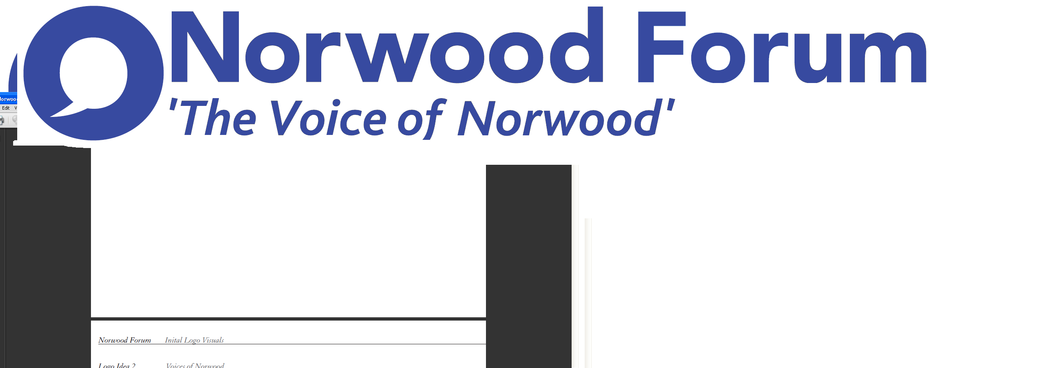
info@norwoodforum.org
Norwood Forum Committee
Thursday 14 September 2017 at 7:00pm
The Old Library 14-16 Knights Hill SE27 0HY
Minutes
Present: Colin Fenn (CF), Sharon Fuller (SF) (part), Su McLaughlin (SMcL), Gloria Orosungunleka (GO) (Vice-Chair), Noshir Patel (NP) (Chair) and Jan Ware (JW)
Apologies: Sunil de Sayrah (SdS) (Treasurer) and Councillor Luke Murphy (LM)
Also present: Councillors Fred Cowell (FC); Sarah Coyte (SC) (Lambeth Council) and Tim Stephens (TS) (Administrator)
Su McLaughlin in the Chair
Note: these minutes follow the agenda order, and not necessarily the order of discussion at the meeting.

- Declarations of interest
There were no declarations of interest.

- Minutes of last meetings and matters arising
The following notes of previous meetings were approved:
Ordinary meeting on Thursday 20 July 2017: matters arising were on the agenda. Councillor Luke Murphy would attend the next meeting to discuss Gipsy Hill issues.
Special meeting held on Thursday 17 August 2017: subject to “West Norwood Advisory Group” reading “West Norwood Cemetery Advisory Group”.
The following actions arising from the special meeting were discussed:
Mission statement: SMcL would draft 3-4 versions and circulate for comment.
Gipsy Hill representation: SMcL would also ask Councillor Luke Murphy for ideas on who to approach.
Council estates representation: NP would now link with John O’Reilly.
Social media policy: NP would ask RA for ideas when asking about the mooted training.
Areas of Activity: TS to collate composite list and circulate for volunteers to lead.
Planning issues: TS to ensure consultations on planning applications are sent to info@norwoodfroum.org. CF advised that enforcement action was not subject to the same consultation processes or responsiveness to public request.
Surveys: SMcL would establish ways the Forum could undertake surveys, e.g.: Facebook and Survey Monkey (check on numbers allowed for free use, and costs otherwise).
WhatsApp group: SMcL had established this; SF would join shortly.
Google suite: would not be free; TS to check on cost and advise NP.
Photos: NP to check on photos held on memory stick.
Planters: SdS had met with Jason Prentis and would look to organise a workshop for local people, probably at The Community Shop and using tools from the Library of Things. All were encouraged to join the Greening West Norwood Facebook group); newsletter item to be drafted once SdS plans in pla0ce).
- Community funding bid: Deerbrook Surgery
SF advised this application was not ready; application to be considered at the next meeting.
- Forum communications
24/7 magazine: SdS had written with a draft advert (£86 cost), and SF set out the possible alternative collaborative approach whereby 24/7 would use and credit 5-6 articles from the Norwood Forum e-newsletter (but retain editorial rights). SF tabled some examples of adverts which would then be free of charge. The deadline for the forthcoming edition was imminent. Agreed that the collaborative approach be pursued for the Christmas edition. SF would identify 5-6 articles that would be suitable and link with NP. The Forum wants to widen distribution of the magazine to reach council estates and other areas currently not covered, but the editor needed to attract more advertising to achieve a higher print run. NP would volunteer the services of the committee to distribute copies and attract advertising.

Logo and strapline: the developer had submitted a quotation of £700. A suggested new logo and strapline had been developed in response to feedback from committee members, using the website font and this was approved. Other colour examples approved for use as appropriate, subject to the social media square version being adjusted to reduce font size of “Forum”.

Website: JW and TS had met to consider comments made by Committee members. A series of issues had been raised with the developer, and requested features were being gradually added and amended. The website banner would be adjusted as agreed (new logo and words on bus). Other comments made could be worked on by committee members once the website was live and the training had been delivered.

Website Committee Member profiles: jpeg photo and profiles should be sent to TS asap.

Website training: TS to link with developer to arrange, with The Old Library training room as a possible venue.

e-newsletter: NP wanted the e-newsletter to reach all businesses along Norwood Road; SMcL would approach the BID manager to establish the best method to achieve this.

- West Norwood Cemetery HLF project
There was dissatisfaction with the Council run consultation questionnaire: the HLF ambition had seemingly been reduced, and the questions were not open in their approach. SC reported on concerns that all sections of the local community were not being reached by the survey, and advised that officers would attend any public meetings on request to present on the consultation. Agreed that CF draft a formal response and consult with NP and Ann Kingsbury, and send this before the deadline of 30 September.
- West Norwood Cinema/ Library
Councillor Sonia Winifred had not responded on the request from NP to call a meeting of the Steering Group and ensure attendance from Picturehouse, or on the requested tour of the building site. The position on London Living Wage was not known. Further article to be included in newsletter.
- West Norwood Heritage and Cultural Hub

FC thanked the Forum for raising the issue (via email from NP dated 02.09.17). These were the related current developments he was involved in:

- The adjoining heritage & cultural hub and KIBA areas needed a new identity (brand) in order to attract inward investment and new businesses. He sought the assistance of the Forum for a new name. The Blackhorse Lane regeneration in North London (funded by Mayor’s Outer London Fund) was an example of the sort of regeneration scheme that was sought for the industrial area and cultural and heritage hub.
- Establishing the cinema opening date.
- Planning enforcement: illegally converted shop fronts. He was to meet planning policy and enforcement officers about both Norwood High Street and Station Rise.
- Local Investment Programme (LIP) funding: he was to meet officers the following week to establish ways of levering in this and other funding to achieve the Master Plan objectives. The CLIP funding position would be known in a few weeks and he would report further at the next meeting.
- He would discuss with regeneration officers holding a private briefing for Forum, BID and NPA members. This would help determine next steps for preparatory work during the winter for possible engagement in spring 2018.

- Streetworks

Waylett Place: FC would chase officers on the implementation plan of actions agreed at the walkabout. It was now urgent to undertake the clean-up and other measures given the pending removal of car parking from Norwood Road. The gates continued to be locked on Sundays, and car owners trying to park legitimately were being ticketed.

Low attendance at Steering Group meetings remained an issue, and now that all meetings were at 5:30pm future attendance by JW was difficult.

- Norwood Planning Assembly
Two task groups (Transport and Site 18) were now set up and volunteers to serve were sought. NP would draft an article for the newsletter.
- Training event for local community
A survey was needed to establish ideas and demand for courses. Language skills was mentioned as a course which was likely to be in high demand.
- Constitution review
Review not required at the current time.

- Building social cohesion and counter extremism within Lambeth
JW would follow up with Rupert Sutton on his visits to other groups and advise if further actions were needed.

- Public meetings
JW had obtained stats from Gipsy Hill but no reply from Knights Hill and stats. were promised from Thurlow Park.
- Chair’s report
NP had nothing further to report.

- Other business
Robson Road: FC reported on efforts to get Thames Water to complete the repair and water supply works at the Norwood Road end. Frequent parking by DHL lorries at the Park Hall Road end had been causing road safety issues.

Norwood Pensioners Group: despite all the efforts made, funding was now almost depleted and its future operation was in doubt.

4All Community Fair (Saturday, 23 September 2017; 2-5pm); NP, SMcL and JW would attend. SMcL and JW would work on a training course survey (see item 10 above). TS to send sign up list to NP; NP would ask SF if a newsletter type handout could be produced.

Next meeting: Thursday 12 October 2017 at 7pm

The meeting ended at 9:25pm.

Action Points {xx.xx.xx} dates = meeting when discussed) | Who | Completed?/  when to be discussed
- Special meeting actions:{14.09.17}:  - Mission statement  - Gipsy Hill representation  - Council estates representation: contact John O’Reilly.  - Social media policy.  - Areas of Activity list  - Planning application consultation and enforcement action  - Surveys  - Google suite  - Photos | SMcL  SMcL  NP  NP  TS  SMcL  TS  NP
- Website: revamp; completion and training {11.05.17; 20.07.17 & 14.09.17} | JW (TS) | 12.10.17
- Website: committee member jpeg photo and profiles {14.09.17} | All | 12.10.17
- Norwood Forum newsletter:  - discuss at every meeting {09.11.16}  - to be sent to all Norwood Road businesses | TS  SMcL
- 24/7: future relationship {15.06.17 & 14.09.17} | NP/SdS/SF
- Accounts 2016-17, budget 2017-18 {05.04.17 11.05.17 & 15.06.17} | SdS | when necessary
- Greening West Norwood: arrange practical session {14.09.17} | SdS
- Community funding bid: Deerbrook Surgery {20.07.17} | SF | 12.10.17
- West Norwood Cemetery HLF project {05.04.17, 11.05.17, 15.06.17, 20.07.17 & 14.09.17}  - Formal consultation response  - Newsletter article | CF>NP/Ann Kingsbury
- West Norwood Cinema/Library {14.09.17}  - Steering Group meeting  - Site visit  - Opening date | NP  NP  FC | 12.10.17

Action Points {xx.xx.xx} dates = meeting when discussed) | Who | Completed?/  when to be discussed
- West Norwood Heritage and Cultural Hub {14.09.17}  - cultural hub and KIBA identity/brand name  - Planning enforcement: converted shop fronts  - Funding of Master Plan objectives; e.g. LIP  - Private briefing for Forum, BID and NPA members | FC | 12.10.17
- Waylett Place: plans {15.06.17, 20.07.17 & 17.09.17} | NP/FC | 12.10.17
- Training event for local community: survey {08.03.17, 05.04.17 & 11.05.17} | JW & SMcL | 12.10.17
- Building social cohesion and counter extremism within Lambeth: any further follow up action {20.07.17 & 14.09.17} | JW
- Public meetings {20.07.17 & 14.09.17} | JW | 12.10.17
- Thurlow Park zebra crossing {05.04.17 & 11.05.17} | NP
- Central Hill Estate: Council’s case and way forward. Discussion with Cllr Luke Murphy {05.04.17, 11.05.17, 15.06.17 & 21.07.17} | NP | 12.10.17

