WALKING ROUTES STREET IMPROVEMENTS PROPOSALS
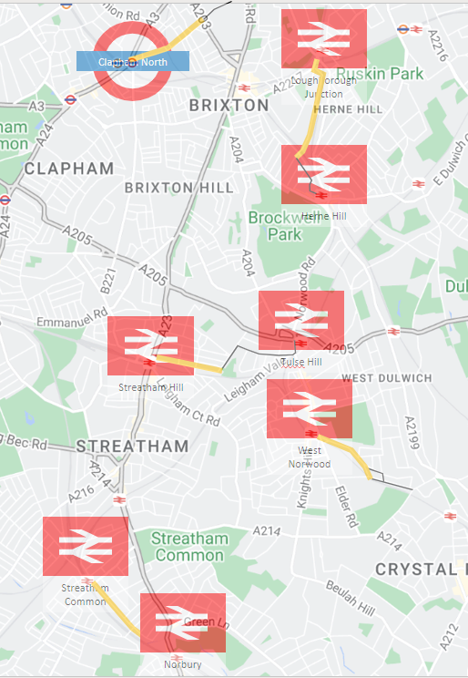

Route 1 – Streatham Common to Norbury (Ellison Road)
Route 2 – West Norwood to Gipsy Road (Auckland Hill)
Route 3 – Streatham Hill to Hillside Road (Amesbury Avenue)
Route 4 – Loughborough Junction to Railton Road (Shakespeare Road)
Route 5 – Clapham North to Stockwell Road (Landor Road)

List of possible street improvements
- Tree build-arounds
- Places to rest (benches)
- Parklets
- Dropped kerbs
- Widen of pavement
- Narrowing of junctions
- Raising junction to pavement level
- Tactile paving
- Additional lighting
- New crossings
- EV charging point
- Electric scooter bays
- Bike sheds/bike parking
- Planters
- Resurfacing pavement

Route Number | Location | Improvement Type | Priority | Comments

Note from Norwood Forum:
This form was prepared by the Lambeth Kerbside Strategy Team. There is no return email so we suggest until we receive that information, that you send your completed form back to us. Please include your name, postcode and email so you can be contacted. We will keep it securely and in complete confidence and share with the Team as soon as we have an email.
So, for the moment, please send your completed form to: info@norwoodforum.org

